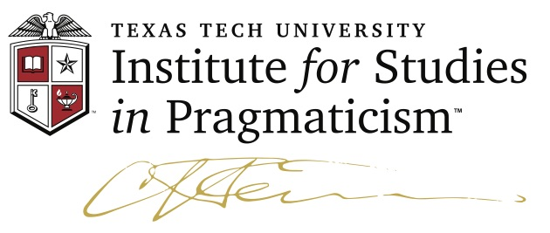

FILENAME: KLKMechanismToInterpretant 22 September 2022

ABSTRACT:
Reviews and responses to The Thanatos Syndrome have been mixed. Some complain it lacks entertainment, others that it describes abuses that are not fit for polite minds. One may propose that excellent literature often uses a bright light to peer into dark scenery. Such is Percy's last novel. One of his beacons reveals mechanistic thought patterns to be a systemic component that enables the kind of abuses described. He also explores the counterpoison for robotic thought systems: human capabilities for interpretation.

From mechanism to interpretant in life sciences
AS exhibited in the thanatos syndrome

by

Kenneth Laine Ketner
© 2022

The higher places in science in the coming years are for those who succeed in adapting the methods of one science to the investigation of another. That is what the greatest progress of the passing generation has consisted in.... Yet in order to adapt to his own science the method of another with which he is less familiar, and to properly modify it so as to suit it to its new use, an acquaintance with the principles upon which it depends will be of the greatest benefit. For that sort of work a man needs to be more than a mere specialist; he needs such a general training of his mind, and such knowledge as shall show him how to make his powers most effective in a new direction.

C. S. Peirce."Introductory Lecture on the Study of Logic,"
Johns Hopkins University, 2 November 1882. CP 7.65-7

Reviews and responses to The Thanatos Syndrome have been mixed. Some readers complain that it is less entertaining than it should have been— because "they say that entertainment is the purpose of art." Others propose that its scenes present horrifying events that should not appear in good literature. (In this case one is presented with criminal activity, incest, child abuse, genocide, and a peculiar form of medical terrorism.)
Instead of a failed effort, contesting reviews can be the mark of a valuable work, because important unresolved issues regarding human nature are forcefully presented, even though the project can only be slowly absorbed with some fortitude. Moreover, literature is art, not just entertainment; it is the kind of art that can present experimental challenges in imaging thought-experiment strategy. Authors of great literature are not indoctrinators. They are presenters of problems. Sometimes those difficulties are not particularly entertaining nor consistent with drawing-room conversational politeness. As Bruce Wilshire observed, "To think about genocide and terrorism is to accept an invitation from hell."
Such a work is Percy's Thanatos (TS). Among all the problems presented in that novel, are there common underlying radical principles that are nourishing the roots of the inhumanities on display? One exemplar is our everyday addiction for mechanistic reasoning coupled with disregard for adequate understanding of interpretational processes.
Mechanistic reasoning is a widespread supposition of contemporary culture. When a puzzling problem arrives, our usual first attempt toward resolution is to ask what has "caused" the difficulty. Seeking the cause has been our "go-to" problem-solving strategy, because it has been assumed that with this tool we could eliminate the offending cause and thereby eliminate the offending problem. Or, given a need to initiate a new condition to anticipate or prevent an issue, if we can acquire the appropriate cause we will succeed.
As we know, Dr. Walker Percy MD was educated at the College of Physicians and Surgeons at Columbia University in New York City. There he would have been widely in touch with the thought patterns of Biological Mechanism, the presupposition still continuing that to solve a problem in life sciences research, one asks "What is the mechanism that produces the difficulty?" A fellow Columbian, professor Eric Kandel, Nobel Laureate in Physiology or Medicine, actively continues that approach by planning to trace the mechanistic path from neurocellular activity to "mind" activity. If such an approach exclusively uses mechanistic tools, Percy proposed in Thanatos, then it will be doomed to failure. The characters and scenes in that novel present thought-experiments displaying persons who are made into drugged machine-creatures who thereby lose their humanity, in particular their capability to perform interpretations.
The mechanistic principle promises that if research is successful, instantiating item A will unavoidably produce item B (where B is something acquired by producing A, or something to be eliminated by eliminating A—vide the famous double-blind research process in medicine). Indeed, these strategies are useful procedures, but the mechanists insist that their suppositions are the exclusive procedure in scientific research, even in the Life Sciences. It is that exclusion that Percy fingers as the skunk in the woodpile, to borrow a pungent rural phrase.
What else besides causation could we use and still retain our scientific reputation?—in the kind of science Percy named Scientism, it is said that we can only experiment on mechanisms. Percy refuted that position within Symbol and Existence (SE), a volume that appeared in 2019, which he had completed much earlier, even prior to publication of The Moviegoer in 1961. If scientific experimentation can be applied to more processes than mechanisms, what features of scientific procedure must be operable? The candidate for addition must be accessible to the procedures of experimentation that begins with a clearly stated predesignated question, a hypothesis that can yield testable experience, public and repeatable observation, experimental results tested against reality, convergence to a result among a community of ethical scientists. I propose Interpretation for this added candidate. Before conducting an experiment on the process of interpretation, we should describe its general setting. When one places attention on an item of thought (the Object O) and notices various features surrounding it (the Representamen R) one employs a relation (the Interpretant I) between that item and those features. The entire process involving O, R, I, is a fact about three items, a triadic relation, the form of which is designated as a Semeiosis, the completed triadic relational activity of interpretation.
At this point a mechanist might speak up to state that "What you suggest is interesting, however, you are discussing abstractions, and it is well known such items are not capable of being the focus of experiments; for example, we cannot observe an interpretation." However, that claim is not true.
As one experiment that exhibits the role of Interpretation in science, observe this image known as the Necker Cube.

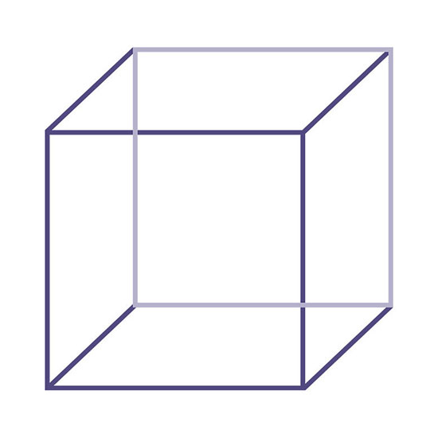

First consider the dark blue square as the front face of the three-dimensional cube. Then refocus to consider the light blue square as the front face. Next proceed to shift between these two conditions so that you can alternatively comprehend either of the two squares as the front. In this experiment what you are literally observing is the result of alternating between two Interpretant factors within a triadic semeiosis relational process that is non-mechanistic, in that one is free (un-caused) to operate with either interpretant. If mechanism were the operative principle, there would be no selection possible between the two alternatives. An efficient causal relationship does not allow two selectable outcomes. One may recall a number of other similar figures such as vase-or-two-faces, the duck-rabbit, or 16 impossible circles.

Two faces and a vase
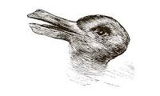
The Duck-Rabbit

The Impossible 16 Circles

Now let us try this with poetry: Stephen Crane — I walked in a Desert.
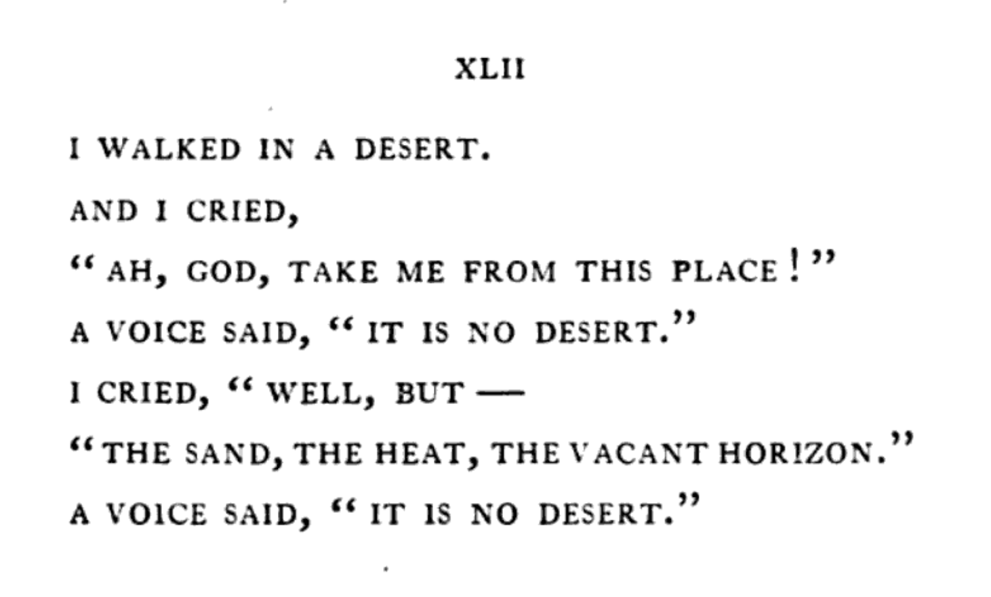
How many interpretations could you experimentally derive from this poem? I will list only a few.
1. Perhaps the main interpretant concerns the principle that "desert" does not only mean an arid location but might indicate a depressed state of mind—then trace out that guide through the poem.
2. Another interpretant might concern "the voice." Is this a divine voice suddenly breaking into consciousness? Or is this the poet conceiving a possibility? Is the poet hallucinating due to desert-induced stress?
3. "A voice said": Does that phrase focus on various meanings for "a saying"; what is the meaning possibility for "to say"?
4. Is this poem about communication between two communicants? If so, who or what are they?
No doubt within classroom exercises many professors of literature have experienced similar presentations yielding differing interpretations. Does that mean that such exposures to literature produce only different personal preferences? If so, that would tend to reinforce the mechanistic view that there is nothing here to experiment upon in an objective fashion, that there can only be personal emotional responses.
Proponents of the possibility that interpretational processes are real, objective, and can be studied experimentaly, would reply that the fact that there are multiple experimentally viable results only shows that such a state is indeed compatible with objective interpretational activities. Furthermore, it is a fact that students in our classes can appreciate another person's different interpretation. One can then retry the differing approach in an experiment that often yields expressions like, "I understand your proposal—that is a real possibility." So now there would be two defensible interpretations. A mechanist looks at the two objective interpretations and, because of allegiance to robotic processes, demands that "There can't be two objective interpretations because mechanism requires only one, so that to have two or more means, again according to mechanism, that those different interpretations must be based on emotion or some other nonrational process such as a disturbed mind."
Here is an important new finding. When interpretation is approached with research tools that allow objectivity for contexts that include more than mechanistic behavior, one finds that multiple well-developed interpretations is a normal factual situation. Such outcomes add to, and confirm, the nature of interpretation as a real, objective process within the context of studies of the science of semeiosis known as Semeiotic. Regarding the example of I Walked in a Desert, the interplay of several viable interpretants could be, in its own right, a whirlwind for comprehending a deeper insight into interacting desert realities. It is in the gaining of individual and shared interpretations that experimentation in art—in the subject-persons encountering art semeioses—that we find using a science like Percy's Radical Anthropology.

* * *
How do these various factors enable a deeper understanding of Thanatos? As an experimental exercise, how do you, readers, answer that question concerning each of these factors? Remember, we have at hand a test of whether Percy's Radical Anthropology is workable for literary theory.

• stop thinking that literature is only entertainment
• stop only seeking the cause
• stop exclusive assumption of mechanism in life

• interpretation is a real event, can be observed, not just a preference
• interpretation is free—mechanism is robotic, forced, other-controlled
• convergence of interpretation is possible through objective processes
???Percy's version of Dante Inferno????

Research Assistant: Chandler Culberth.
Bruce Wilshire, Get 'em All! Kill 'Em!: Genocide, Terrorism, Righteous Communities. Lanham: Lexington Books, 2004. See his Wild Hunger; also Ketner, "Our Addictions," Review of Wild Hunger: The Primal Roots of Modern Addiction, in Contemporary Pragmatism, 2004, volume 1: 157-167. In the short preface for Thanatos (viii) Percy acknowledged a book that had influenced him: A Sign for Cain: An Exploration of Human Violence, by Frederic Wertham, M.D. New York: Macmillan, 1962.
Kandel, Eric R. et al, editors. 2021. Principles of Neural Science. New York: McGraw Hill
Interdisciplinary Seminar on Peirce. 2019. "Toward Understanding the 'Biology of Mind' Hypothesis." In Peirce Studies number 10, 17-57. Berlin: Peter Lang GmbH; Kandel, Eric R. 2006. In Search of Memory: The Emergence of a New Science of Mind. New York: W. W. Norton & Co. Percy read an earlier article by Kandel on the Biology of Mind approach.
Compare pages 2-5 in Symbol and Existence, A Study in Meaning: Explorations of Human Nature by Walker Percy. Edited by K.L. Ketner, K.L. Perkins, R.R. McDonnell, and S.R. Cunningham. Macon: Mercer University Press.
Stephen Crane. 1895. The Black Riders and Other Poems. Boston: Copeland and Day.

