Percy's Interest in Neuroscience

and

His Search for *The Coupler*

By Kenneth Laine Ketner © 2017

../../../Desktop/ISPnewLogoFolder/send/color/Institute%20logo%20color.pdf

For SAMLA Conference

November 2017

Atlanta, Georgia

Literature is a fantastically important aspect of human life. It is not an educational “frill” nor merely a means for entertainment to pass some time. But what is it, and how does it arise in a talented author? Walker Percy’s life and work provides an excellent focus for study of this issue. Today I shall attempt just one small aspect of that topic.

Percy was a very well-educated scientist/physician, who attended a distinguished university at Chapel Hill, and graduated from a top medical school—the College of Physicians and Surgeons at Columbia University. His bout with tuberculosis gave occasion for a two-decade self-guided education in the humanities—roughly 1940-1960. He emerged at the end of that period with an award-winning novel, *The Moviegoer*. Critics wisely noted that Kierkegaard and other existentialist thinkers influenced that effort. Of this there is no doubt, but it wasn't the sole factor. During those twenty years, these additional interests,

• solid preparation in science,

• deepening religion, and

• growing study of Charles Peirce's hypotheses about

interpretation and meaning,

also became well established in Percy's "search" to understand human nature.

These four focal points continued throughout his career as a writer. There is a tendency for students of his work to think that literature was the heart of his later career, while scientific studies were a feature only in early times: There is growing evidence now that this is not accurate. I want to consider an example from the later period—roughly 1980s—showing how expanding research in neuroscience reached Percy's worktable and from which he drew some encouragement for support of his hope to identify a "coupler." Then I will propose some testable hypotheses about the nature of Percy’s “coupler.” There is an excellent review of Percy’s thoughts about the coupling agency in human consciousness—what unites “body” with “mind”—in Perkins (2011, 178 f.). Her research shows that Percy sought a piece of matter—some brain tissue—to perform the requisite coupling.

Percy stayed informed on developing research in neuroscience. For example, in *The Message in the Bottle* (1975) he mentioned Geschwind’s study (chapter entitled "A Theory of Language") related to the issue. He also tracked some of the seminal articles of Nobel Laureate Eric Kandel—also from Columbia University—on the “Biology of Mind” as we can see from his annotated copies of those studies (Percy Archive, University of North Carolina at Chapel Hill). Thus, one cannot infer that Percy was seeking a coupling factor only as a writer without being abreast of important developments in neuroscience.

What is the question for which Percy’s “coupler” hypothesis is an answer? It is roughly this: What connects bodily sensations, perceptions, neurological processes so that mental phenomena appear?

I propose that coupling does occur, but it is not between two different kinds of items—body and mind: rather, (1) such coupling occurs between two or more items of the same kind, and (2) the coupling is of the same kind. Whatever form it takes, Mind/Body dualism requires a dichotomy of two differing kinds; in the classic case of Descartes’s thinking, it is *res extensa* (material substance) and *res cogitans* (thinking substance). If one takes this dualism as a fundamental given, then one has to answer how a human being can be a combination—or coupling—of those two radically different items.

If Percy’s proposed *material* coupling entity is to perform appropriately, it will, by hypothesis, have to be, in turn, coupled to the two (or more) items it is to couple. The problem is, then, that any given material coupler proposed will, when put in action, require at least two more material couplers, and each of those additional couplers, will in turn require two more such coupling features, and so on *ad infinitum*. So, it appears that finding another hunk of matter to be a Percy coupler does not solve the problem but instead compounds it. Does this mean that Percy’s search for a proper coupler is to be unsuccessful?

While the above factor seems discouraging, we can take heart because while pondering the above features, one is led to another point in Percy’s writing wherein perhaps he *did* solve the issue, but—one might propose—maybe he did not categorize that particular point as the “coupler solution.” I am referring to section 15 of “The Delta Factor” (Percy 1975, 39). Here is his statement, including his important footnote:

15

A NONLINEAR NONENERGIC

NATURAL PHENOMENON

(that is to say, a natural

phenomenon in which energy exchanges

account for some but not all

of what happens) [*]

*I am aware of course that other phenomena can be described in a sense as nonlinear, e.g., action of a force field, gestalt perception, transactions in a neural net, etc. Yet these events lend themselves to formulations by equation and to explanatory models which discern this or that causal or statistical relationship within a structure.

The utterance or understanding of a sentence does not so lend itself.

This is a claim that there are natural phenomena that are not exclusively causal nor material in nature. As Percy noted in the same page, Charles Peirce agreed and described this additional reality as *Semeiosis* (*sign* in the broad sense), which is a natural phenomenon possessing triadic relational features. For an example, consider:

“A functioning weather vane (**Representamen**: a narrow-sense *sign*)

indicates the direction of the wind (**Object**, of the broad-sense *sign*)

to an observer (**Interpretant** within the broad-sense *sign* or semeiosis process).”

Percy was inclined to dismiss Peirce’s hypothesis on this point as “metaphysics”; however, that is a misreading. Peirce was a scientist who proposed as a laboratory hypothesis that semeioses were real features of the world that are open to experimental study. That is, Peirce proposed that the world was composed of *existing* items such as pencils and propellers *as well as* *relational realities* such as one finds in a fire-tower occupant’s call that “There is smoke at grid 13—check for a fire!” or the successful understanding of a communicated sentence or comment (see Ketner 2011).

Maybe the key here is that Peirce’s relational realities, particularly as they can be found in semeioses, are exactly the NONLINEAR NONENERGIC NATURAL PHENOMENON (***NP***) Percy discussed, *and* ***NP*** also provides us with an answer to the question about the nature of the coupler. If so, the answer for “What is the coupler?” is:

The “What” is not an existent item such as bodily tissue;

but

The “What” is a ***NP***, specifically one or another semeiosis *relation*.

Why might Percy have not come to think of ***NP*** as a resource for solving the coupler question? The footnote as cited above is revealing: He stated that actions of a field or of a neural net are nonlinear: meaning “are noncausal.” Thus, he pointed to exactly the appropriate examples. A *field* is a law-like relational phenomenon such that items within the field relate according to the field laws. Consider the classic magnetism experiment with a bar magnet covered by a sheet of paper sprinkled with iron filings. The magnetic field is the zone around that magnet wherein the relations of the field laws control orientation of the iron particles. We have the magnet, a given particle, and field law. Thus, the *orientation of particles* is a fact about those three items: magnet, iron particle(s), law. And remember that a law is more than a list of previous observations. Its *generality* provides reliable expectations for the future or for reading the past. So, a magnetic field is precisely an instance of ***NP*** and is also a semeiosis in a manner analogous to weathervanes that are capable detectors of a field known as *wind*. This shows that physical science, both physics and biology, contain natural relational phenomena that Percy described as ***NP***, or that Peirce described as semeioses.

The difference between the two researchers is that Percy wants standard science to always be concerned with linearities, or causal relations only; so, if one finds a phenomenon such as ***NP*** that is not completely causal—as indeed it isn’t—then for Percy it is not a part of science. Such a causal/material science was appropriate and acceptable for him. If, however, such an understanding of science were to be elevated to an all‑encompassing worldview that denied phenomena such as ***NP***, Percy would regard that elevation as inappropriate (Percy 2019, preface 1 f.).

Percy’s strategy here was to deny the elevation of causal/material science, and then to seek a way to understand ***NP*** outside of the only kind of science he accepted: namely the kind that merely dealt with causes and materials.

But Percy has overlooked one of his own accomplishments. Suppose there are other objective, natural phenomena in science besides causes and materials. Peirce argued that science is about whatever is found to be really the case independently of egocentric or arbitrary desires. If one follows that guidance, one finds that relations of any valency are really to be found in scientific study, and that they can be studied objectively. So, science can study relations of valency one (“That object is black”), of valency two (“Fire causes smoke”), of valency three (“An electron was raised to the next energy level by an incoming photon”), of valency four (“John sold his car to the junk dealer for $5)” and so forth. It does not matter that the results of science are expressed in everyday language or in the language of mathematics and carefully drawn special terminology, nor does a mode of expression force one to think that scientific phenomena are exclusively causal (valency two) expressions.

If this hypothesis is correct—that the coupler Percy sought is indeed ***NP*** or triadic semeioses—then what relevance might there be for literature? Although there is no time for it at the moment, perhaps we can foresee that poets, essayists, novelists also deal in real relations. Moreover, a successful literary art event in which a reader “takes the writer’s meaning” is also an instance of semeioses (Percy 2018). Because semeioses are observable realities it follows that literary semeioses may also be objectively studied. In his studies of ***NP*** as outside of his understanding of science considered only as causal/material, he did objectively discover (see the referenced works by Percy) valuable scientifically observable features of semeioses that are relevant to science, but not covered by scientism.

Thus, we may conclude that there is no need to look for a special material coupler located in a special kind of place. Semeioses are objectively observable in everyday life, in physics, in the biology of neurons, in social activity. Coupling is everywhere there is intelligibility. With a slight adjustment to Percy’s general understanding of science, by admitting real relations such as semeioses as matters for scientific study, one can relieve a paradox in his research approach. The clarifying step he needed was to admit real, natural semeioses into the scope of science, as Peirce did. Percy’s study of symbols and his semiotic were objectively scientific in that expanded sense, so then his results will stand as an example of pioneering findings of the science of semeiotic.

Scientism—the elevation of exclusively causal/material science to be an emperor of all knowledge and comprehension—dies hard. Percy knew this well (Ketner 2018). Yet we can see that there is a broader sense of science, as the objective approach to realities no matter of which kind. Percy was not the first to comprehend this. Peirce was soaked in the topic. From the literary side, there have been many similar voices that could sing in Percy’s choir. One such fascinating figure is D. H. Lawrence (1936). Another possibly similar perpetrator is Edgar Allen Poe in his *Sonnet to Science* and his late book *Eureka*. It appears that there might be a tradition for this sort of thing that has survived *sub rosa* over the ages.

REFERENCES and background notes

Kandel, Eric R. 2006. *In Search of Memory*. New York: Norton.

Ketner, Kenneth Laine. 2011. "Semeiotic." In *Das Bild zwischen Kognition und Kreativität*. Edited by Elize Bisanz. Bielefeld: transcript Verlag.

_____. "Rescuing Science from Scientism: The Achievement of Walker Percy." *The Intercollegiate Review*, vol. 35, no. 1, Fall 1999, pp. 22-27.

Lawrence, D. H. 1936. “Why the Novel Maters.” In *Phoenix: The Posthumous Papers of D. H. Lawrence*, 533-538. Edited by Edward D. McDonald. London: William Heinemann Ltd. Accessed at: https://archive.org/details/in.ernet.dli.2015.77133

Percy, Walker 1975. *The Message in the Bottle*. New York: Farrar, Strauss, and Giroux.

_____. 1992. *Lost in the Cosmos*. New York, Farrar, Strauss, and Giroux.

_____. 2018. "To Take the Writer's Meaning. Edited by K. L. Ketner. In Leslie Marsh, Editor. *Walker Percy, Philosopher*. Cham: Palgrave Macmillan.

_____. 2019. *Symbol and Existence*. Edited by K. L. Ketner, K. L. Perkins, R. R. McDonnell, S. R. Cunningham. Macon Georgia: Mercer University Press.

Perkins, Karey Lea. 2011. *Walker Percy and the Magic of Naming: The Semeiotic Fabric of Life*. Atlanta: Georgia State University.

Samway, Patrick S.J. 1995. *A Thief of Peirce*. Jackson: University Press of Mississippi.

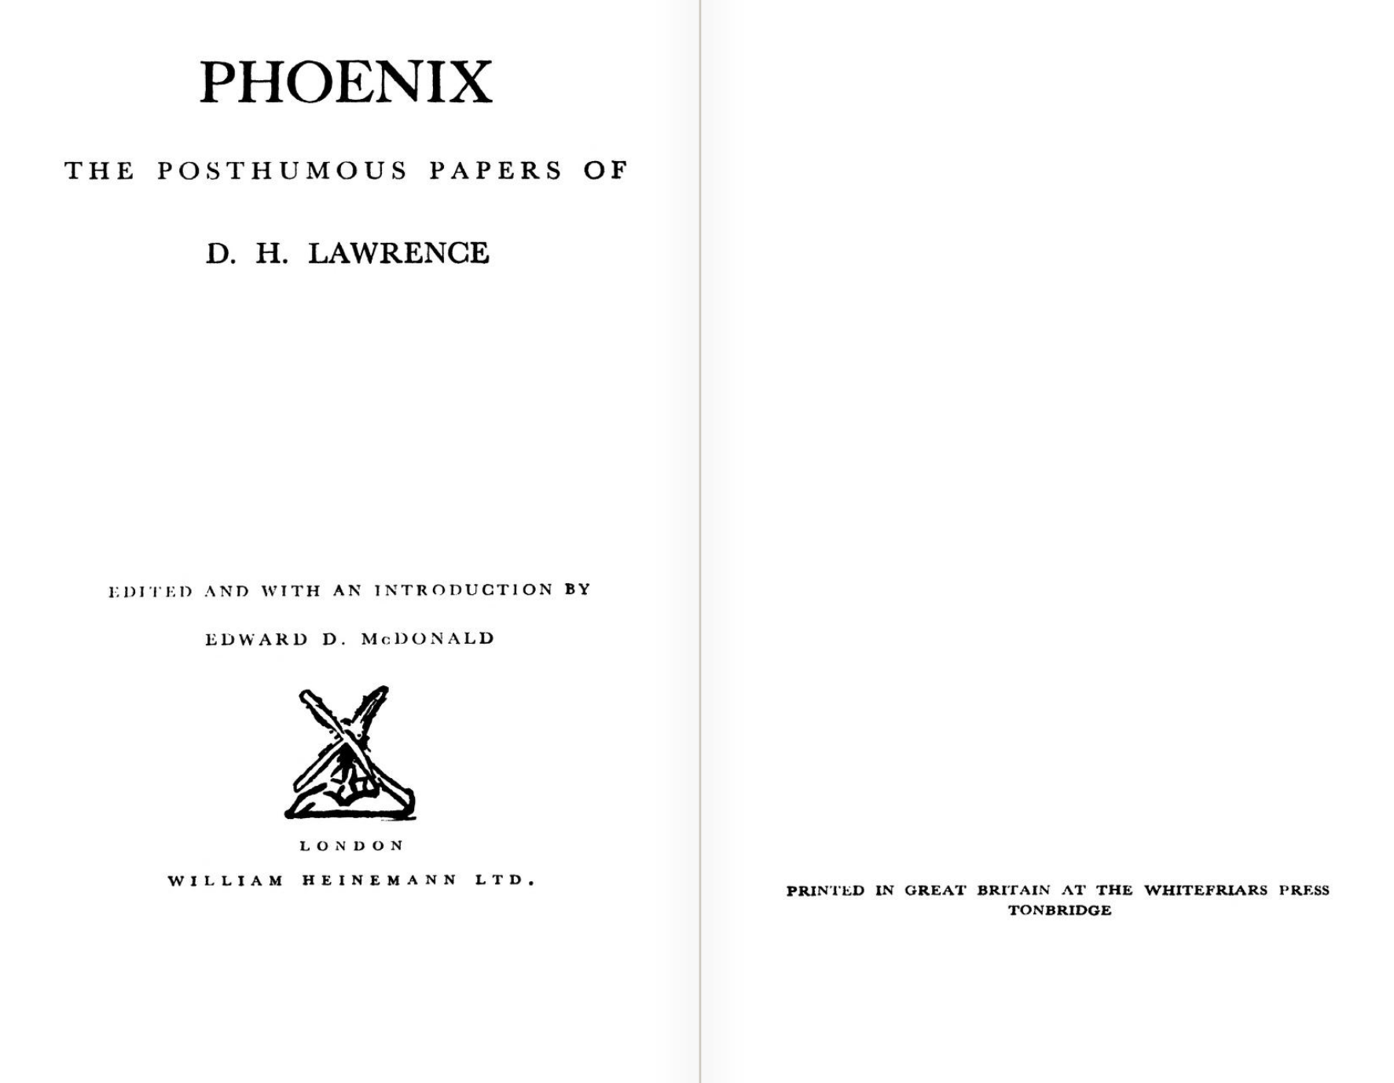

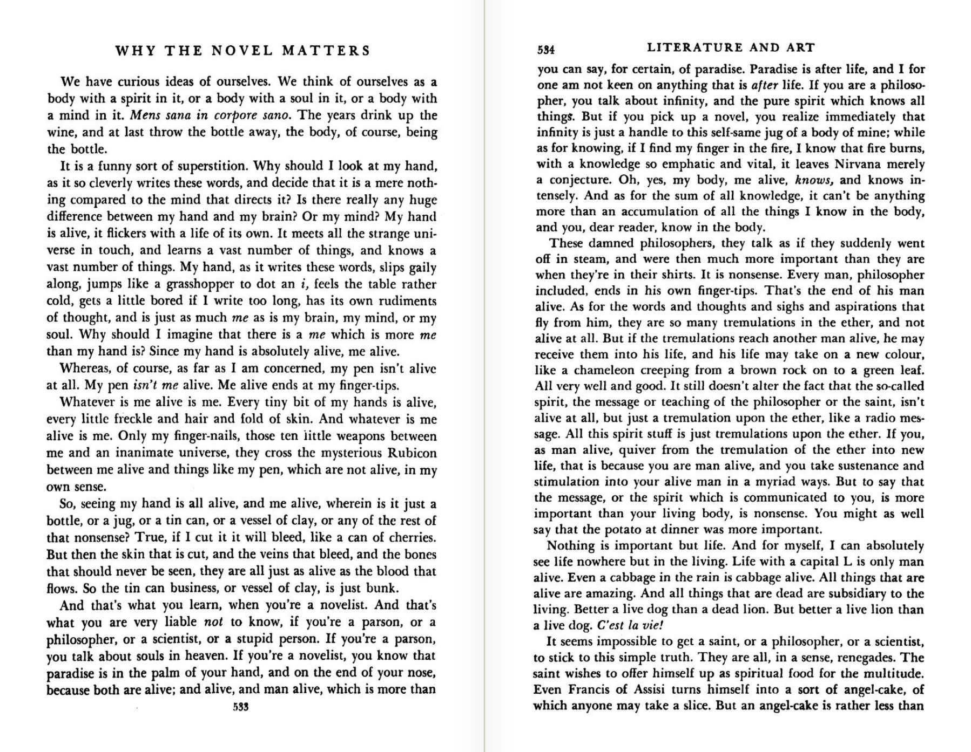

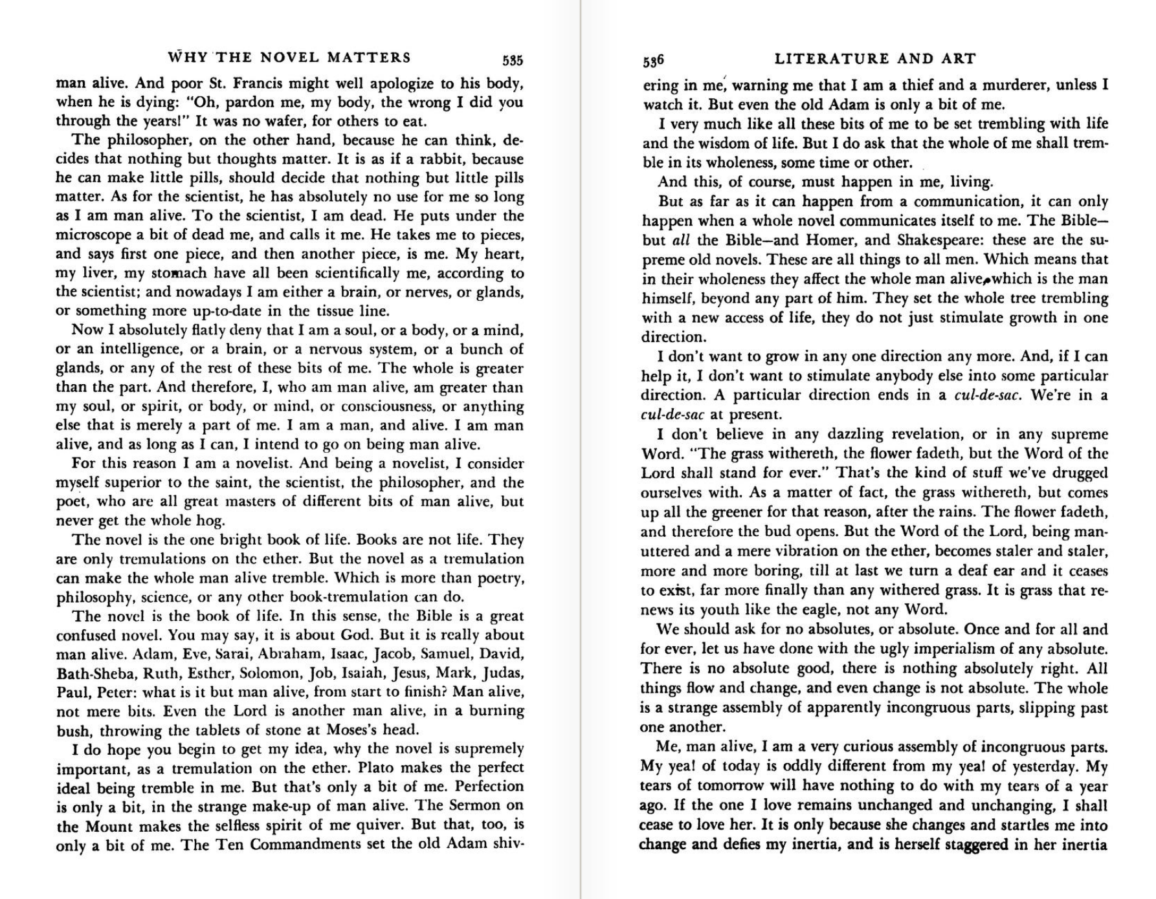

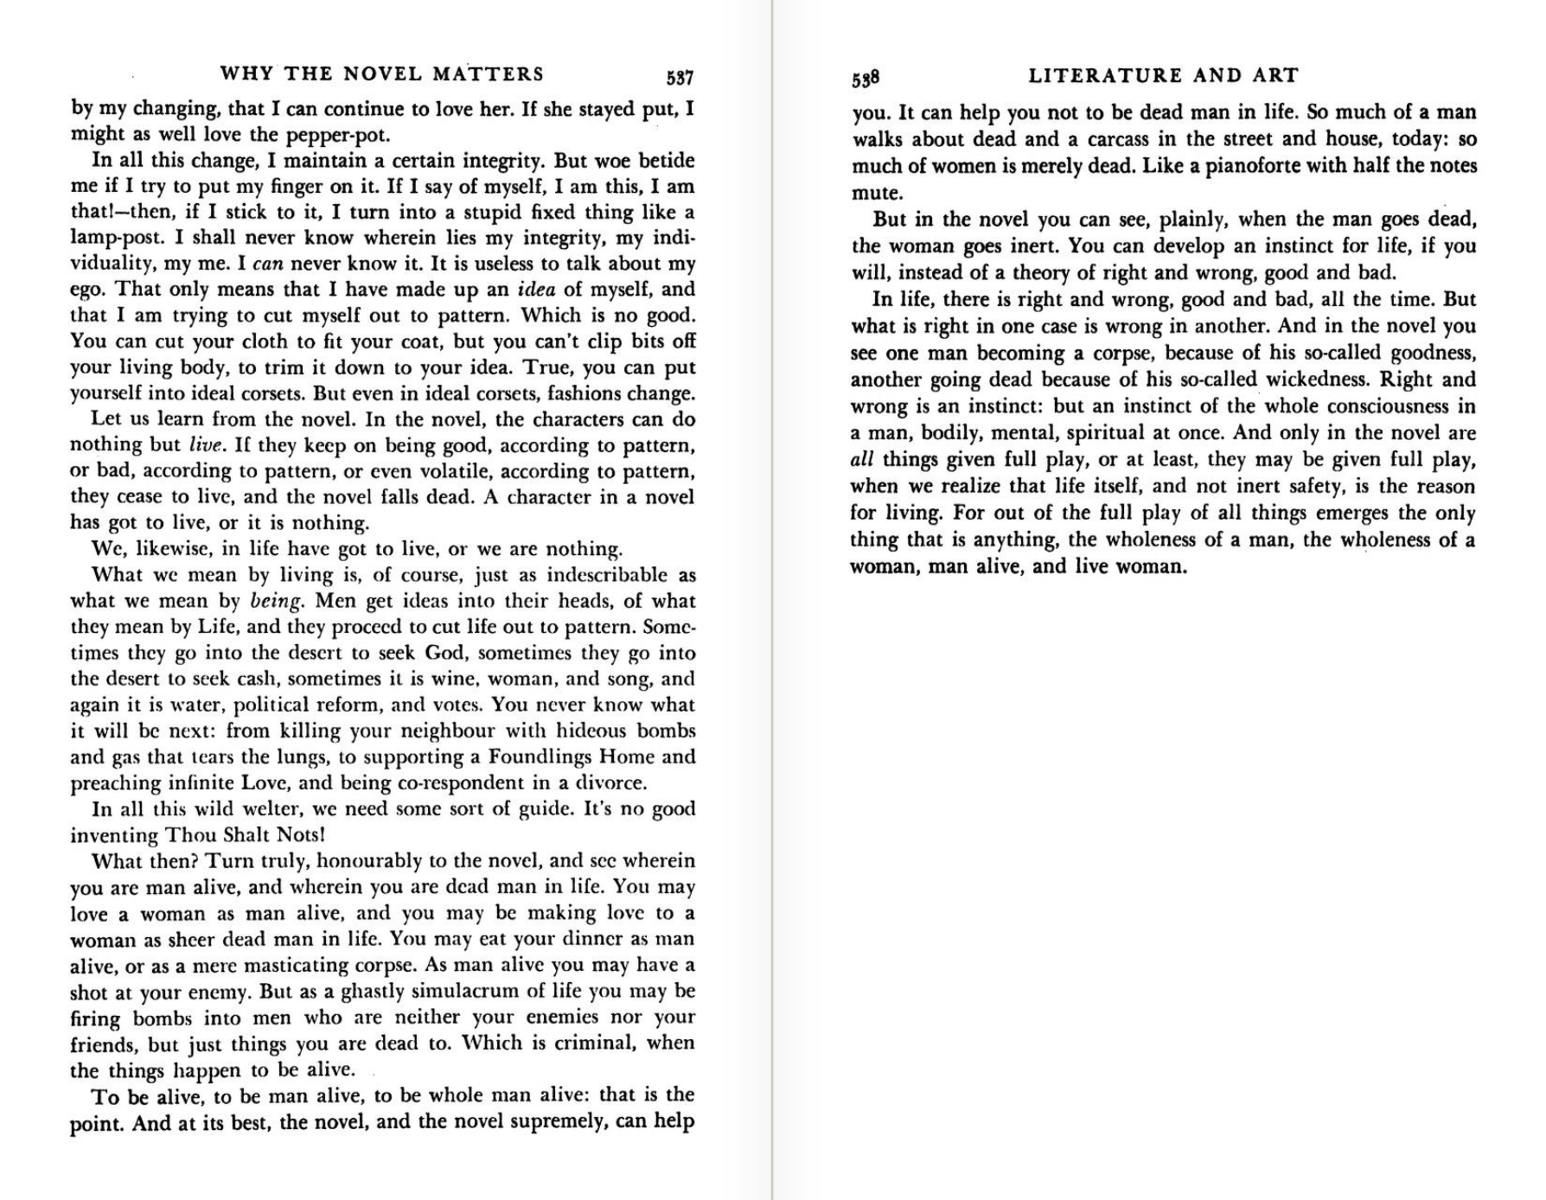

BACKGROUND STUFF

What question motivates the “coupler”?

Role of Veatch’s Intentional Logic; identity issue in Veatch.

Percy’s letters to a Physician friend, in KLK notes from UNC visit. Probably on S&E backup stick at house….not on DB!

Columbia. Kandel. Why did this interest WP, his coupler hypo.

<https://www.washingtonpost.com/graphics/2017/lifestyle/your-brain-on-art/?hpid=hp_hp-top-table-main_sa-kaufman-1216pm%3Ahomepage%2Fstory&utm_term=.2380f3e04d16>

Walker Percy's Search for the Coupler

I would  like to work up a paper on:

“Walker Percy’s Search for a Coupler.”

He sought to heal the Cartesian Mind/Body gap, *in some new way*. As a physician, anatomist, and pathologist (M.D. Columbia University), he was inclined to locate an organic site operating as a body/intellect coupler. His general plan resembles that of Nobel Laureate Eric R. Kandel (Professor, Columbia University) who proposes a “Biology of Mind” research path. Percy read some of Kandel’s seminal work on this project. Through their intersection, one might locate factors that illuminate the research strategies of both scientists. Notably, Percy produced novels—such as *The Thanatos Syndrome*—that arise from his scientific project, whereas Kandel is producing biologically informed accounts of art (*The Age of Insight*). Finis

I could say more about how this approach could develop into an analysis of the WP triad/dyad, body/soul, soul/ego/self, sign/signal, Morris/Peirce tracks, for the project does threaten to explode into those swamps. But maybe the best strategy for something like this is to avoid schlucking into the “good news” bayou.

folder 443 $$$$$

WP reads and annotates a copy of an article on "The Neurosciences and Behavior: An Emerging Biology of the Mind." Article appears to be a review of Kandel and Schwartz, PRINCIPLES OF NEURAL SCIENCE.

File contains various clipped articles on THE BRAIN. This is one, includes pp. 19-22 of an article, A7 size paper, featuring Kandel's work with aplysia. WP annotates various passages.

Article is from Col. P&S, WP's MD school.

folder 572

Jerry M. Lewis M.D.—WP, 12 January 1983.

WP has asked Lewis for articles on psychiatry. In his letter, Lewis states:

"Finally I enclose a copy of Kandel's provocative essay "Psychotherapy and the Single Synapse." It seems to me that although his work is focused on primitive organisms, it reflects the perspective that is respectful to both human experience and neurotransmitters."

folder 496

WP reads and annotates "Voice in the Wilderness: How Humans Acquired the Power of Speech," in THE SCIENCES, published by the New York Academy of Sciences, July/August 1988, pp. 22 f.

The article knocks Chomsky (obscurantist) and introduces recent work. WP marks (p. 24) "Contrary to Chomsky and like-minded linguists, then, modern man is what he is not DESPITE evolution but BECAUSE of it. Biologists, of course, have always taken this as an article of faith. ///WP marks/// But now, for the first time, the idea can be proved; the biological bases of speech have been identified."

folder 428

WP-Professor Thornton (Weldon? at UNC dept English), 6 November 1979

Having just received a copy of Panthea's book [Panthea Reid Broughton edited *The Art of Walker Percy: Stratagems for Being*. Baton Rouge: Louisiana State University Press, 1979.] and having just read your generous article, [Weldon wrote in Broughton’s edited book “Homo Loquens, Homo Symbolificus, Homo Sapiens: Walker Percy on Language.] I want to thank you. ....

Considering the leisurely gestation of Panthea's book, you might well have forgotten some of what you wrote (if you're like me), so I won't comment at any length except to plead guilty to the charge of anatomical crudity at the end of "A Theory of Language". My defense is that If triadic theory is true, some such neurophysiological analogue must exist in the brian—so you can imagine how pleased I was to discover that GeschWind had found what could only be the "base" of the semiotic triangle: the massive interconnections between the auditory and visual cortical radiations. Okay, "the inferior parietal lobule" does sound like one of Dr. Thomas More's nutty theories—but it's there, and not there (or only rudimentarily there) in other primates and I'm delighted. WP